Geometry-informed Magnetic Sensing for Real-time control of a Soft Wrist-assistive Device
First Author1, Second Author2, and Third Author3*
1School of Mechatronic Systems Engineering, Simon Fraser University, Canada
2University of Groningen, Kapteyn Astronomical Institute, the Netherlands
3California Institute of Technology, USA
* Corresponding.Author@sfu.ca

ABSTRACT
Amplitude tuning is an important strategy in animals employing traveling wave patterns, enhancing their adaptability to unstructured environments. This article proposes, for the first time, an amplitude tuning method that leverages the compliance of a soft corkscrew by twisting its ends. An amplitude tunable traveling wave robot (ATW Bot) is developed, consisting of a soft corkscrew housed in a high-degree-of-freedom cage and driven by only two servos. The soft corkscrew and cage are monolithically 3D-printed. The ATW Bot achieves a wide range of active amplitude tuning with passive compliance adaptation and can extend its morphology to a coiled configuration, enabling clamping and rolling. A comprehensive model is built for the twisted soft corkscrew geometry, proving that the robot’s speed is decoupled from amplitude variations during twisting. A genetic algorithm is used to optimize the soft corkscrew for achieving the fastest speed while matching the cage geometry. Experiments demonstrate that the combination of active amplitude tuning and passive body compliance enables the robot to adapt to unstructured terrains including slits, steps, gaps, converging tunnels, slopes, and swimming.

Keywords: Strategy, Amplitude Variations, Engineering Discipline, Finite Element Analysis, Optimization

I. INTRODUCTION
Wearable robotic devices have seen a remarkable rise in tandem with the rapid technological advances of the past decades [1], [2]. Initially inspired by industrial machines, exoskeletons have been conceived to assist human movements to both mitigate musculoskeletal strain and injuries in workers [3] – [5], and restore motor functions in impaired individuals [6] – [9]. More recently, we are witnessing the emergence of soft robotic exoskeletons: lightweight, portable, textile-based devices that assist human motion without constraining natural biomechanics [1]. Yet, the full potential of exosuits critically depends on their ability to accurately detect and interpret the user’s intentions, and deliver timely assistance [10] – [12]. Current intention detection strategies can be broadly categorized as (i) methods based on mechanical events (kinematic or kinetic transduction) [6], [13], [14], (ii) methods based on neuromuscular activity (e.g., electromyography) [15]– [17], and (iii) methods based on multi-modal sensing and sensor fusion [18], [19]. Although neuromuscular signals offer the theoretical gold standard for human–machine interfacing, pure mechanical-event-based approaches remain far more common in practice due to their robustness and simplicity.

These systems typically rely on arrays of sensors such as load cells, encoders, pressure sensors, and strain gauges to identify gait phases or joint kinematics [16], [20], [21]. Most exosuit designs have adopted inertial measurement units (IMUs) [1], [6], [8], which indirectly reconstruct joint motion by fusing data from accelerometers, gyroscopes, and magnetic fields [22]. Magnetic tracking, of both permanent magnets and coils, has recently emerged as a promising alternative for human–robot interaction [30], [31]. Permanent magnets, in particular, offer distinct advantages over coil-based systems: they generate stronger fields while functioning as passive, wireless markers that require no power or wiring. These features have enabled diverse applications such as tracking ingestible capsules [30], [32], [33], medical instruments [34], [35], and monitoring artificial and biological organs. More recently, magnetic tracking has been explored in virtual reality and aerodynamics. While its potential for joint tracking has been demonstrated in various applications, no previous work has addressed its integration in wearable robots.

In this study, we integrated magnetic tracking into a soft tendon-driven exoskeleton to assist wrist pronation and supination (Fig. 1). The new device features an embedded permanent magnet in a mobile frame connected to the skin, two magnetometers in a fixed frame for angle tracking, and one reference magnetometer for geomagnetic field compensation. Magnetic data (B¹, B², and B³) are collected and processed via nonlinear optimization to extract the robot angle θ. The latter can be used to impose reference torques τ_{ref} or angles θ_{ref} to a low-level controller for an electric motor, controlling its torque τ_{M} or angle θ_{M} to implement an appropriate control policy (e.g., a finite-state machine).

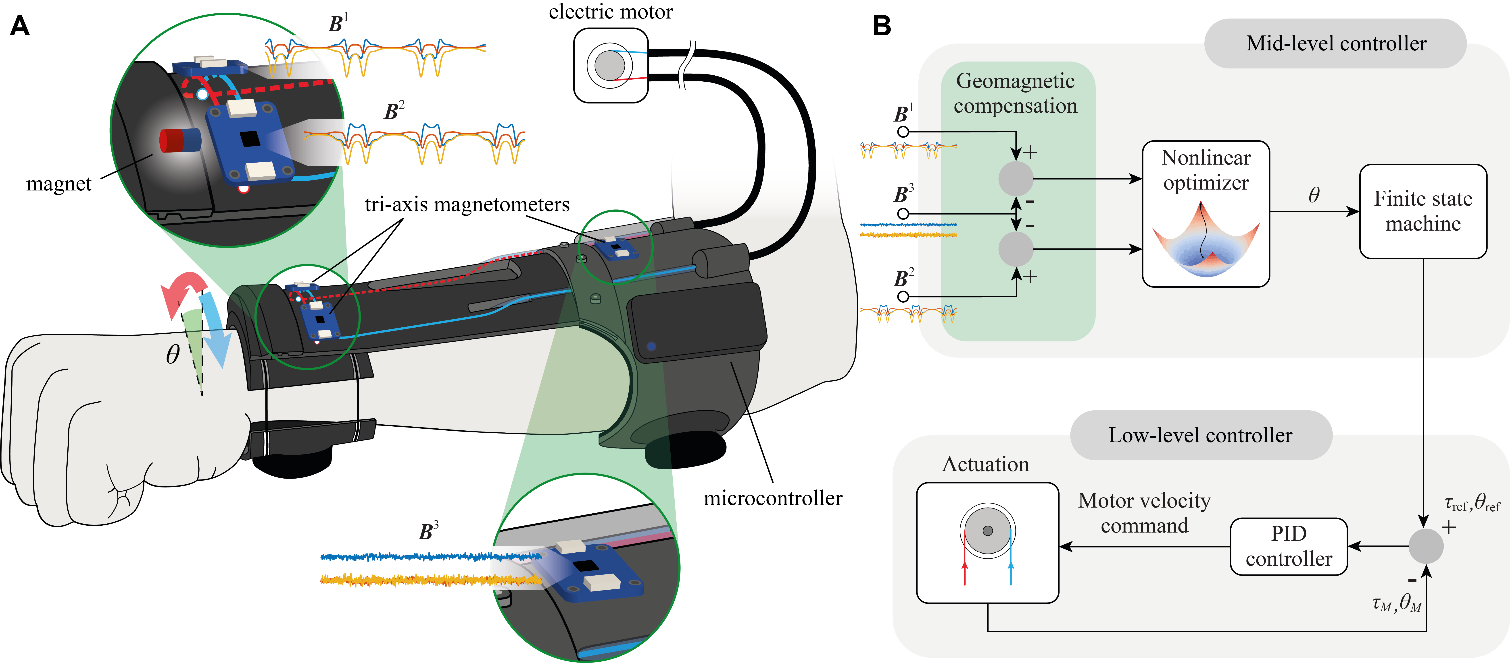
Figure 1. Magnetic tracking concept for a wrist-assistive wearable robot. (A) Illustration of the adapted exosuit design proposed by Su et al. [9], (B) Overview of the exosuit control scheme.

The contribution of this work is a geometry-informed magnetic tracking architecture that reduces the tracking problem by exploiting the constrained kinematics of the wrist-assistive mechanism. This enables real-time estimation using two tracking magnetometers, with an optional reference magnetometer for geomagnetic compensation. The present validation focuses on controlled benchtop accuracy, stability, sensitivity to selected disturbances, and a qualitative proof-of operation in the device controller. Finally, we integrated this sensing strategy into the exosuit’s control loop, demonstrating real-time position-based motion assistance in a single participant trial. By extending magnetic tracking into wearable robotics, this work establishes a foundation for a new class of reliable, accurate, and minimally obtrusive sensing technologies, applicable to soft robotic exoskeletons.
$θ=arctan {\left(\frac{r_{x}}{r_{y}}\right)}^{4}$ Equation (1)
Using Equation (1), Magnetic sensing for joint monitoring can be realized via encoder-based approaches [41], [42]. In the most common arrangement, a diametrically magnetized magnet is attached to the rotating shaft, while a Hall-effect sensor is fixed to the stator, with both components aligned along the same axis (on- axis configuration) [43]. As the shaft rotates, the magnetic field orientation changes and can be uniquely mapped to the shaft angle from the measured planar field components (Fig. 2A). An alternative off-axis configuration places the sensor away from the shaft axis but still aligned with the magnet center (Fig. 2B). Although planar field information is sufficient to reconstruct angular position, this setup requires calibration.

II. METHODOLOGY
- Hardware Design
The sensing module integrates the magnet, magnetic sensors, a small LiPo battery (3.7 V, 500mAh), and microcontrollers within a wristband and cuff assembly (Fig. 4C). Two tendons, routed through Teflon tubes and tendon sheaths in the cuff, connect anchor points on the wristband to the remote actuation system. A slider–rail mechanism couples the wristband to the cuff, enabling actuation-driven pronation–supination of the forearm. For magnetic sensing, we embedded in the wristband a cylindrical N42 NdFeB magnet (Supermagnete, Germany; L_{m} = 8 mm, R_{m} = 2 mm). Three digital tri-axis magnetometers (MLX90393, Melexis, Belgium) were instead integrated in the cuff: two distal sensors positioned near the embedded magnet for tracking, and one proximal sensor used as a reference to compensate for the geomagnetic field (Fig. 4A). Sensor data were sampled at 340 Hz over I2C (400 kbit/s) and processed by a Teensy microcontroller (PJRC, Oregon, USA), which implemented the tracking algorithm. The Teensy also computed joint angle and transmitted it via UART to an Adafruit Feather nRF52 (Adafruit, New York, USA), which relayed the data wirelessly over Bluetooth Low Energy (BLE) at 100 Hz (Fig. 4C).

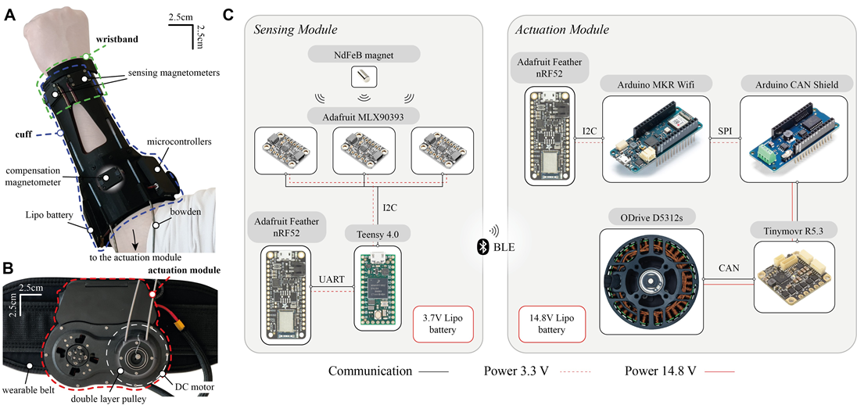
Figure 4. System architecture. (A) Sensing module components overview, (B) Actuation module components overview, (C) Components that are embedded within the sensing and actuation modules

- Real-time Mid-Level Controller
The output of the tracking algorithm was integrated into a finite state machine (FSM) that determines the reference motion for the device (Fig. 5). The FSM comprises seven states, with transitions triggered by the estimated device angle θ and angular velocity θ˙. The states are: Rest (R), Pronation (P), Complete Pronation (CP), Supination to Rest (SR), Supination (S), Complete Supination (CS), and Pronation to Rest (PR). We set the convention that pronation corresponds to a clockwise rotation, while supination corresponds to a counterclockwise rotation. A benchtop validation was designed to characterize the proposed sensing approach in terms of accuracy, precision, latency, sensitivity to external disturbances and geomagnetic field. In addition, we compared our geometry-informed magnetic tracking method with a non-geometry-informed magnetic tracking algorithm from the literature [46]. Vision-based ground truth was obtained by attaching four ArUco markers to the wristband (arranged as two pairs) and tracking them with an RGB camera (Logitech C920, Logitech, Switzerland) to compute the reference angle θ_{camera}(t).

- Benchtop Validation and Qualitative Controller Demonstration

A continuous 3-hour recording was collected with the device mounted on the handle (Fig. 6A). The camera provided the reference θ_{camera}(t) for accuracy assessment. This dataset was used to quantify short-term accuracy against vision, compare magnetic tracking versus IMU-based estimation and the reference algorithm [46], and assess long-term stability and drift. To benchmark computational latency at maximum band- width, the device was run for 5 minutes using only magnetic measurements (no camera or IMU logging). The resulting log of cycle times was used to characterize acquisition and inference time under real-time operation.

III. RESULTS AND DISCUSSION
- Validation against Vision Reference

To probe sensitivity to disturbance location, 5 repetitions were performed with the object positioned near S1–S2 and 5 repetitions with the object positioned near S3. To assess resilience to changes in the ambient field due to device re-orientation in space, we collected a 5-minute recording while moving the device in space during actuation (Fig. 6C). We recorded magnetic-tracking output and IMU data to evaluate stability as the device’s orientation relative to the Earth’s magnetic field changes. (Geom Mag) closely matches vision feedback (R2 = 0.99), with errors confined between –4◦ and +2◦ and a characteristic wave-like distribution associated with sensor arrangement. ArUco marker detection was processed in Python, while IMU quaternion data were used to reconstruct the relative angle of motion. The IMU-based quaternion output was obtained directly from the sensor’s onboard fusion of gyroscope, accelerometer, and magnetometer data following the corresponding calibration procedures.

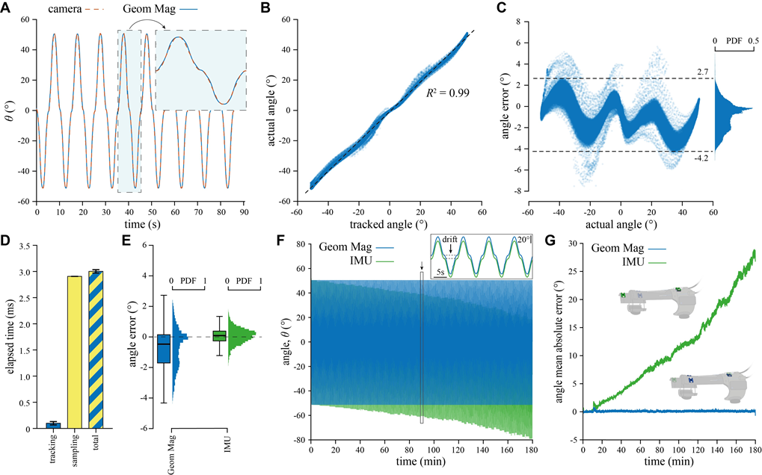
Figure 7. Accuracy and temporal stability of magnetic tracking, (A–C) Geometry-informed magnetic angle tracking, (D) The method achieves high-speed performance (>300Hz), with deterministic sampling and minimal inference time (≈ 60µs), (E) Accuracy comparison of magnetic tracking and IMU w.r.t. vision in the first 6 min of recording, (F-G) Angle mean absolute error of the magnetic tracking approach (blue) and the IMU (green)
In the tested benchtop condition, magnetic tracking showed no measurable degradation of the vision-referenced error over the 3-hour recording, whereas the tested IMU implementation accumulated drift. Following the selected disturbance protocol, magnetic tracking showed limited error increases under several common disturbance sources (power transformer, smartphone, metallic pliers, and steel springs), which did not measurably increase the error relative to the no-disturbance condition. Larger errors were observed with the drill (powered on) and magnetic tape, with median errors around 1.7◦ and peak errors up to approximately 5.6◦; these increases were statistically significant compared to the reference condition (Friedman test with Bonferroni-corrected post-hoc comparisons). The strongest disturbance occurred with an external permanent magnet of comparable size to the embedded magnet, which increased the median and maximum errors to 2.2◦ and 8.4◦, respectively, and was significantly higher than all other conditions. Despite this worst case, the impact on the perceived device behavior remained visually limited.

- Short-term Accuracy and Long-term Stability

The use of the additional magnetometer did not significantly alter the overall accuracy (Fig. 8C, D). The presence of the third sensing magnetometer (S4) improves the accuracy of the angle calculation only close to the center of the mechanism and close to one of the two ends of the range of motion (i.e., of the positive angles, Fig. 8C). Yet, when visualizing the distribution of the two angle errors (Fig. 8D), error ranges remain more or less the same, i.e., [−4◦, +1◦] versus [−4◦, +2◦] of the standard 5 DoFs reported in [46] and our 3 DoFs implementation, respectively. In the user demonstration, the participant successfully activated all controller states, enabling both pronation and supination assistance (Fig. 10). The device operated in torque control, as indicated by the close agreement between the reference torque and the measured motor torque throughout two complete cycles.
IV. CONCLUSION
This study presented a minimal magnetic-tracking approach for estimating the pronation-supination angle of a wrist-worn device using only two tri-axial magnetometers. By explicitly embedding the mechanism kinematics into the tracking formulation, reliable angle reconstruction can be achieved with fewer sensors than typically used in magnetic tracking. The resulting nonlinear least-squares problem is solved with a Levenberg–Marquardt scheme and remains compatible with real-time control. To contextualize the proposed approach within wearable joint sensing, Table I summarizes key tradeoffs across different modalities. In this paper, magnetic tracking achieved R₂=0.99 with errors typically within [−4◦, +2◦] and sub-degree median error, comparable to the tested IMU-based estimate during short recordings. However, under the same experimental conditions, IMU-based estimation exhibited substantial drift over multi-hour operation (∼ 6◦ after 1h and ∼ 28.91◦ after 3h), whereas magnetic tracking showed no measurable degradation over the 3-hour benchtop recording. This comparison should not be interpreted as a general benchmark for all state-of- the-art IMU hardware or sensor fusion algorithms; rather, it highlights the temporal stability of the proposed magnetic sensing approach.

Table 1. Comparison of Wearable Sensing Modalities
Wearable sensing modality | Cost & scalability | Sensitivity to skin–device sliding | Signal processing complexity | References
Magnetic tracking  (Permanent magnet +  magnetometers) | Low–medium;  scalable (few  cheap | Moderate; depends on stable module placement on the limb | High; nonlinear model-based estimation  (e.g., LM) +  calibration/constraints | This work
IMU  (accel+gyro +/-mag) | Low–medium; mature commercial and scalable technology | Moderate–high; soft-tissue motion/ strap slip can bias segment orientation and joint axes | Medium–high; sensor  fusion + calibration;  constraints/resets often required for drift reduction | [23]  [24]
Capacitive wearable  sensors  (Textile/elastomer  strain/bend) | Low–medium;  scalable via textile  manufacturing | Moderate–high;  migration changes mapping and may  require recalibration | Medium; calibration curves/regression +  filtering based on the  application | [27]  [29]

A geometry-informed low-footprint magnetic sensing strategy for tracking the pronation-supination angle in a soft wearable device was presented in this article. By embedding the mechanism kinematics into a model-based optimization framework, the method achieved vision-referenced accuracy of R₂ = 0.99 and with RMSE ≤ 1.59◦ (error within [−4◦, +2◦]), supported real-time operation (>300 Hz), and showed no measurable degradation over multi-hour recordings. Selected disturbance experiments showed limited sensitivity to several representative objects, with larger but still bounded errors under strong magnetic sources. Overall, these results establish the proposed method as a compelling alternative to conventional motion-tracking technologies. By extending magnetic tracking into wearable robotics, our work opens new perspectives on robust sensing strategies for human–machine interaction.

REFERENCES

- M. Xiloyannis, R. Alicea, A.-M. Georgarakis, F. L. Haufe, P. Wolf, L. Masia, and R. Riener, “Soft robotic suits: State of the art, core technologies, and open challenges,” IEEE Transactions on Robotics, vol. 38, no. 3, pp. 1343–1362, 2021.
- H. van der Kooij, E. H. van Asseldonk, M. Sartori, C. Basla, A. Esser, and R. Riener, “Ai in therapeutic and assistive exoskeletons and exosuits: Influences on performance and autonomy,” Science Robotics, vol. 10, no. 104, p. eadt7329, 2025.
- M. P. De Looze, T. Bosch, F. Krause, K. S. Stadler, and L. W. O’sullivan, “Exoskeletons for industrial application and their potential effects on physical work load,” Ergonomics, vol. 59, no. 5, pp. 671–681, 2016.
- S. Crea, P. Beckerle, M. De Looze, K. De Pauw, L. Grazi, T. Kermavnar, J. Masood, L. W. O’Sullivan, I. Pacifico, C. Rodriguez-Guerrero, et al., “Occupational exoskeletons: A roadmap toward large-scale adoption. methodology and challenges of bringing exoskeletons to workplaces,” Wearable Technologies, vol. 2, p. e11, 2021.
- Y. M. Zhou, C. J. Hohimer, H. T. Young, C. M. McCann, D. Pont- Esteban, U. S. Civici, Y. Jin, P. Murphy, D. Wagner, T. Cole, et al., “A portable inflatable soft wearable robot to assist the shoulder during industrial work,” Science Robotics, vol. 9, no. 91, p. eadi2377, 2024.
- E. Tricomi, F. Missiroli, M. Xiloyannis, N. Lotti, X. Zhang, M. Ste- fanakis, M. Theisen, J. Bauer, C. Becker, and L. Masia, “Soft robotic shorts improve outdoor walking efficiency in older adults,” Nature Machine Intelligence, vol. 6, no. 10, pp. 1145–1155, 2024.
- J. Kim, F. Porciuncula, H. D. Yang, N. Wendel, T. Baker, A. Chin, T. D. Ellis, and C. J. Walsh, “Soft robotic apparel to avert freezing of gait in parkinson’s disease,” Nature medicine, vol. 30, no. 1, pp. 177–185, 2024.
- R. Ferroni, G. D’Avola, G. Sciarrone, G. Right, C. De Santis, J. Carpaneto, M. Gandolla, G. Del Popolo, S. Micera, and T. Proietti, “A multi-joint soft exosuit improves shoulder and elbow motor functions in individuals with spinal cord injury,” Nature Machine Intelligence, pp. 1– 13, 2025.
- H. Su, K.-S. Lee, Y. Kim, and H.-S. Park, “A soft, wearable skin-brace for assisting forearm pronation and supination with a low-profile design,” IEEE Robotics and Automation Letters, vol. 7, no. 4, pp. 12078–12085, 2022.
- J. Babicˇ, M. Laffranchi, F. Tessari, T. Verstraten, D. Novak, N. Sˇ arabon, Ugurlu, L. Peternel, D. Torricelli, and J. F. Veneman, “Challenges and solutions for application and wider adoption of wearable robots,” Wearable Technologies, vol. 2, p. e14, 2021.
*Disclaimer: The article “Geometry-informed magnetic sensing for real-time control of a soft wrist-assistive device (2025)” by Federico Masiero et al. was used as a reference to develop this sample template. No content from the original publication were used in any way for research or academic purposes.

